
HEALTHCARE
ANALYTICS ON HEART DISEASE DATA

DETAILED PROJECT REPORT

Madhvendra Singh

PROJECT DETAIL

 |  |  | Project Title | Healthcare Analytics on Heart
 |  |  |  | Disease Data
 |  |  | Technologies | Business Intelligence | Data
 |  |  |  | Analysis
 |  |  | Domain | Healthcare
 |  |  | Project Difficulty Level | Advanced

2021 DETAILED PROJECT REPORT 2


OBJECTIVE

The goal of this project is to analyse the occurrence of heart disease in a person based on a combination of features that describe the heart disease.

2021 | DETAILED PROJECT REPORT | 3


PROBLEM STATEMENT

Health is real wealth in the pandemic time we all realized the brute effects of covid-19 on all irrespective of any status. You are required to analyze this health and medical data for better future preparation.

A dataset is formed taking into consideration information of some individuals. Find key metrics and factors and show the meaningful relationships between attributes of the dataset.

2021 DETAILED PROJECT REPORT 4


DATA SET DETAILS

The fourteen features in Dataset we refer to are:

- Age: Age of different individuals in years

- Sex: Gender of the individuals [1=Male , 0=Female]

- Cp: Describes the Chest Pain experienced [0:aymptomatic , 1: Atypical

Angina , 2: Non-Anginal Pain , 3:Typical Angina]

- Trestbps: Describes the Resting Blood Pressure in mm/hg

- Chol: Describes the Serum Cholesterol Level in mg/dl

- Fps: Describes the Fasting Blood Sugar > 120 mg/dl [0 = no, 1 = yes]

- Restecg: Describes the Resting ECG

[0: showing probable or definite left ventricular hypertrophy by Estes’ cr

iteria, 1: normal, 2: having ST-T wave abnormality]

2021 DETAILED PROJECT REPORT 5

DATA SET DETAILS

- Thalach: Describes the maximum heart rate achieved

- Exang: Refers to Exercise Induced Angina [1 = yes, 0 = no]

- Oldpeak: Refers to ST depression induced by exercise relative to rest

- Slope: Describes the slope of the peak exercise ST segment

[0: downsloping; 1: flat; 2: upsloping]

- Ca: [number of major vessels (0–3)

- Thal: A blood disorder called thalassemia

[1 = normal, 2 = fixed defect, 3 = reversible defect]

- Target: Heart Disease [0 = disease, 1 = no disease]

2021 DETAILED PROJECT REPORT 6



INSIGHTS

2021 DETAILED PROJECT REPORT 7

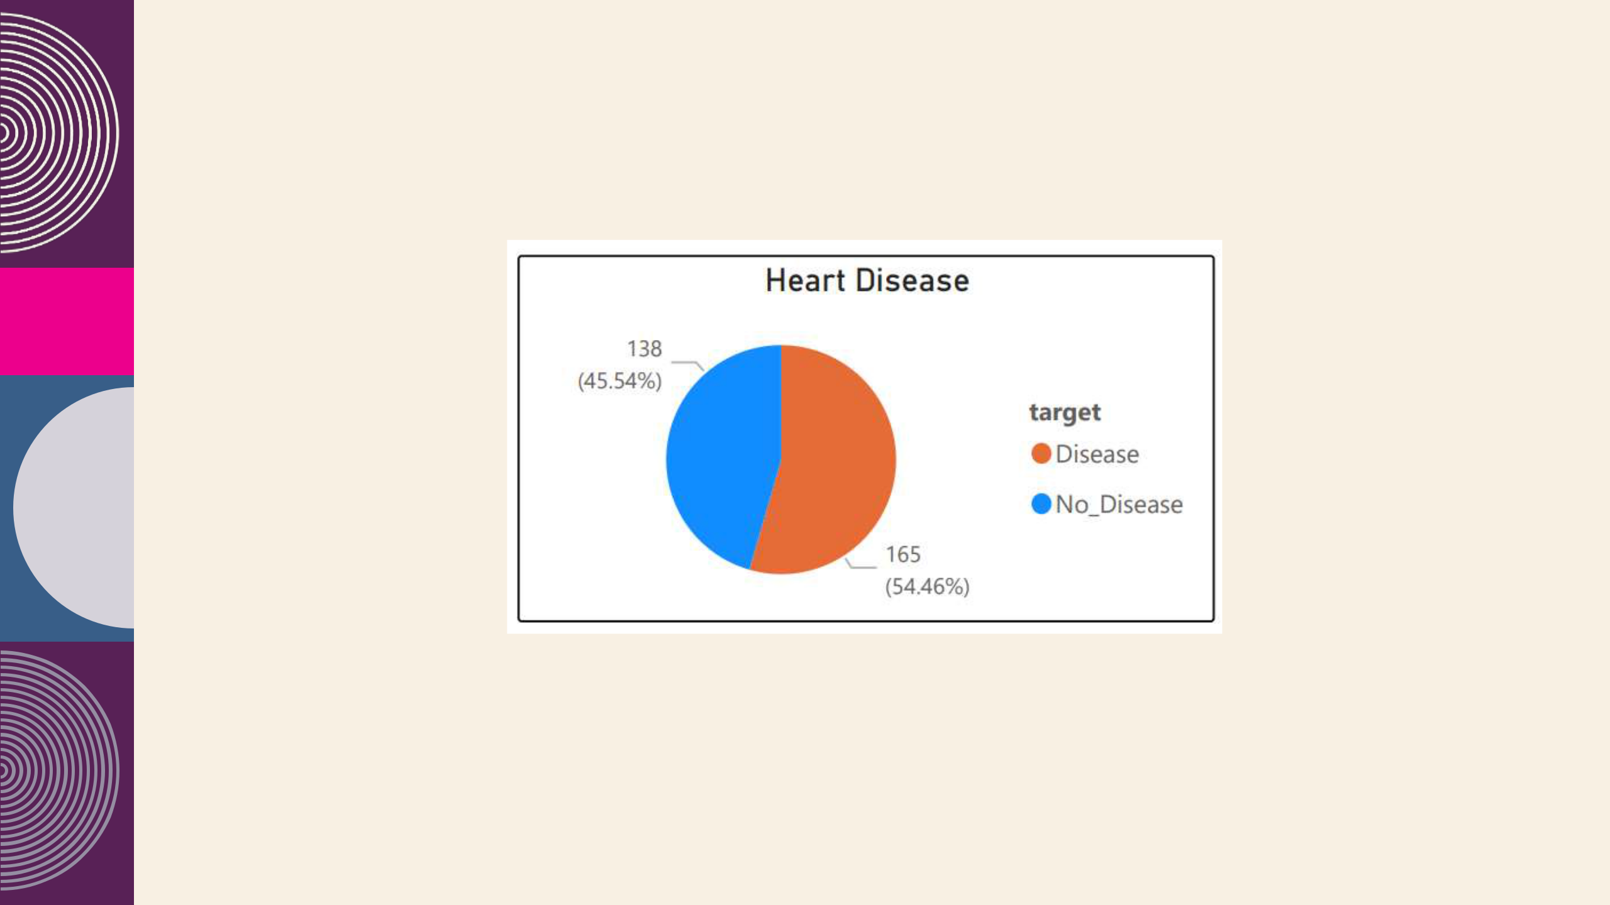
POPULATION

Disease accounted for 54.46% of Count of targe

2021 DETAILED PROJECT REPORT 8

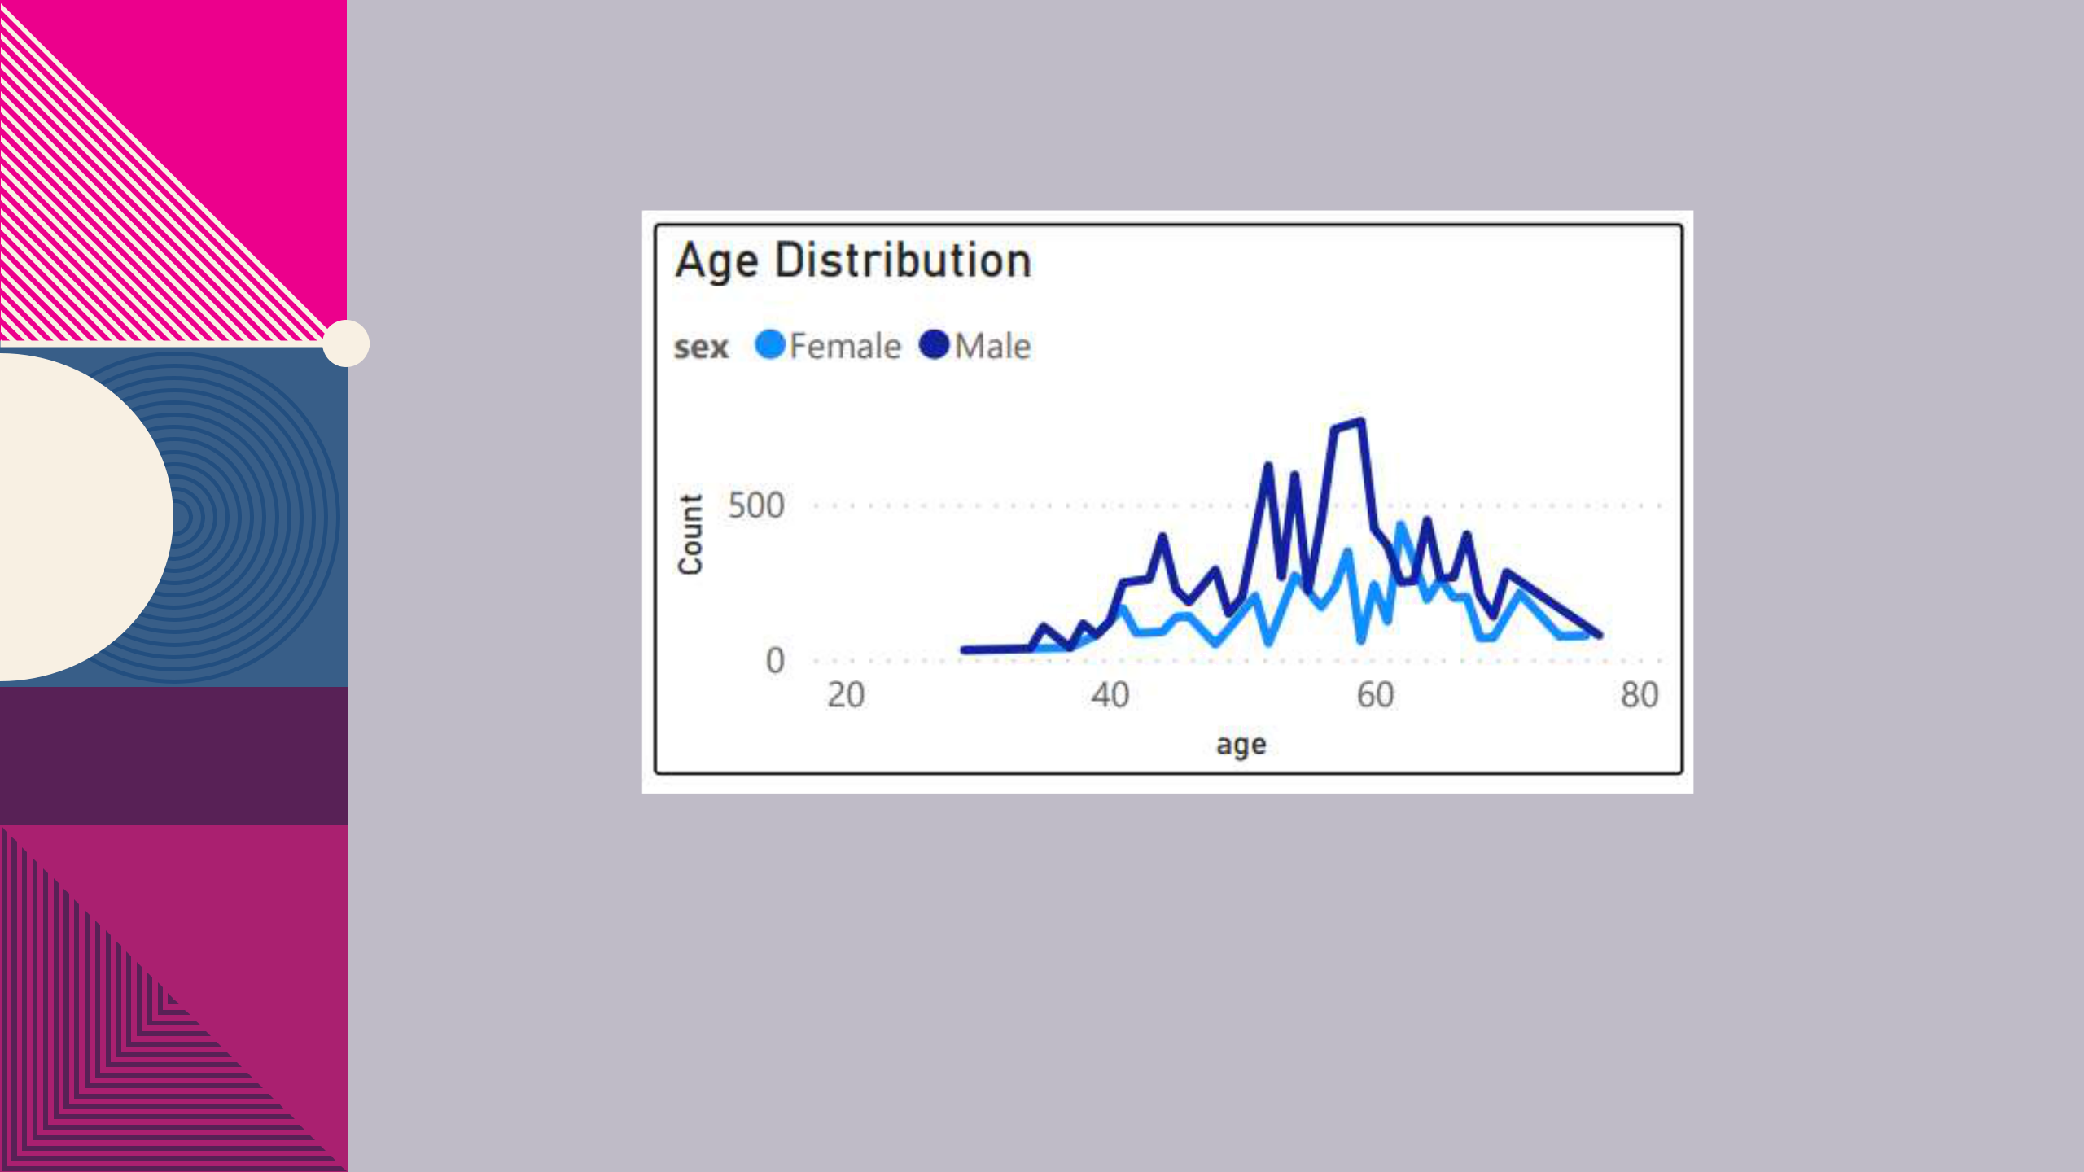

$2B $1B

- Freedom to invent

- Selectively inclusive market

- Serviceable available market

Average age was higher for Male than Female

2021 DETAILED PROJECT REPORT 9

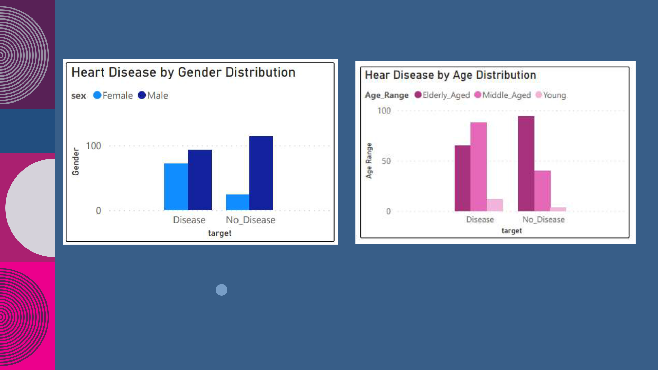

Males are more prone to heart diseases |  |  | Middle Aged people are most affected by Heart
 |  |  | Disease

2021 DETAILED PROJECT REPORT ₁₀

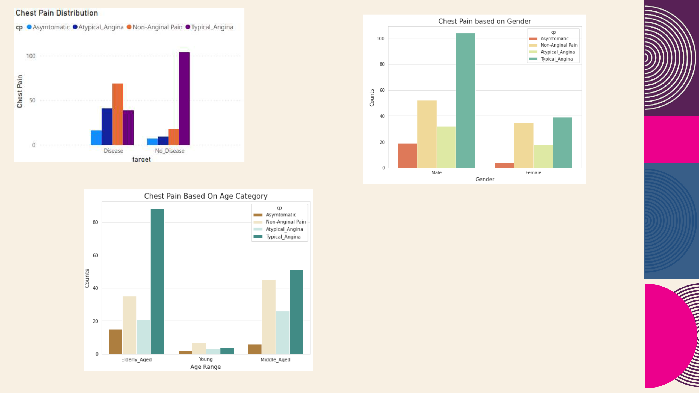

higher number of healthy subjects have Typical Angina

We can see that a higher number of men are suffering from Typical Angina of Chest Pain

2021 | subjects in Elderly Age category i.e. above 55 suffer from Typical Angina | 11

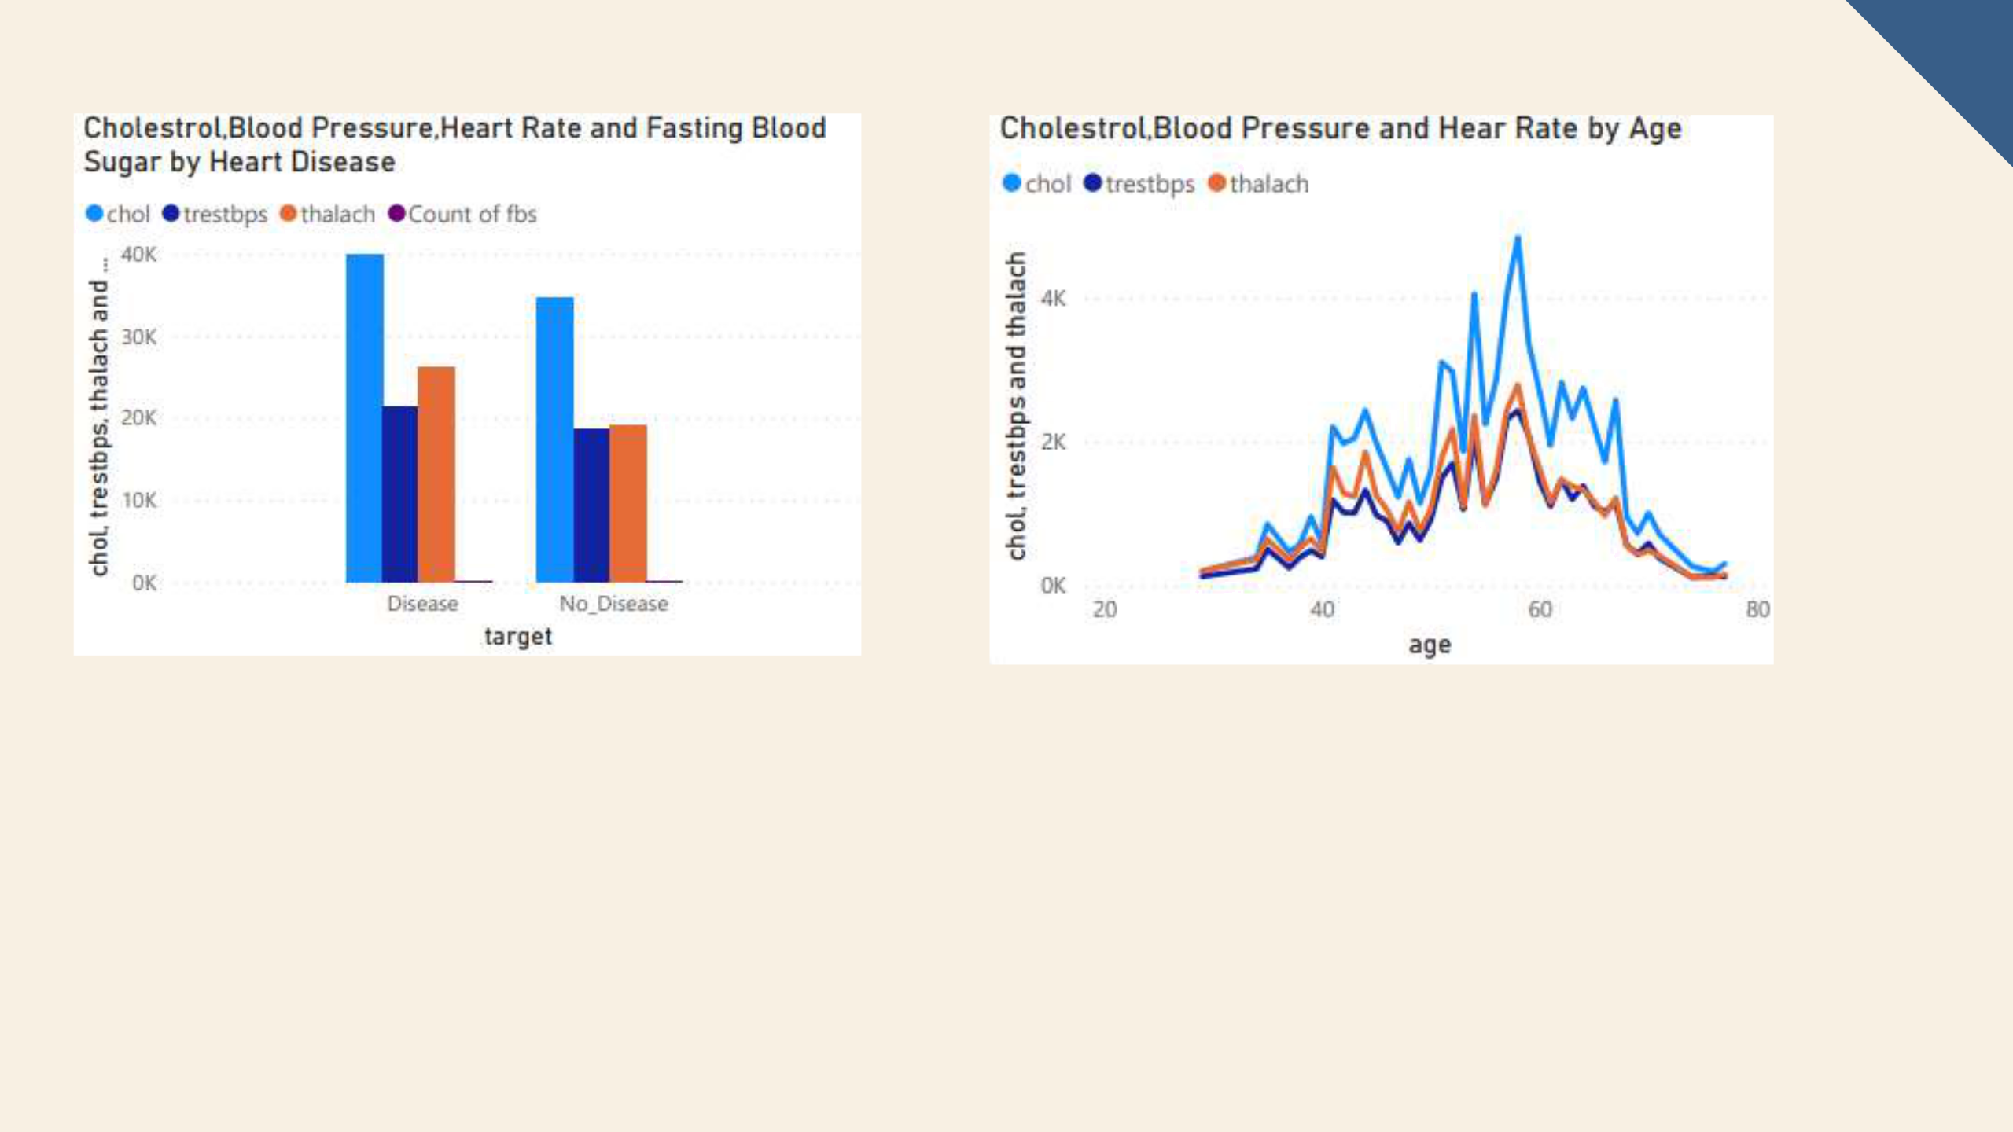

chol and total trestbps are positively correlated with
each other.
CONCLUSION

- People suffering from heart disease constitutes of 54% of the total population.

- Most of the patients are in the age group 50-60.

- Middle Aged people are most affected by Heart Disease

- higher number of healthy subjects have Typical_Angina can be subjective to stress, physical activities and many more and varies between gender.

- higher number of men are suffering from Typical Angina of Chest Pain

- Blood Pressure Levels are almost equal in both Males and Females

- Higher Blood Pressure Level results Chances Of Heart Disease

- Higher Cholestrol Levels results chances of Heart Disease

- ,there are higher number of heart disease patient without diabetes.

2021 DETAILED PROJECT REPORT 13

